Aeronautical System B
Final Report
BY
THU TA ZAW

(1) Build a glider using styrene sheet, balsa wood rods, and weights.

The glider has been constructed by using styrene sheet, balsa wood rods and weights.

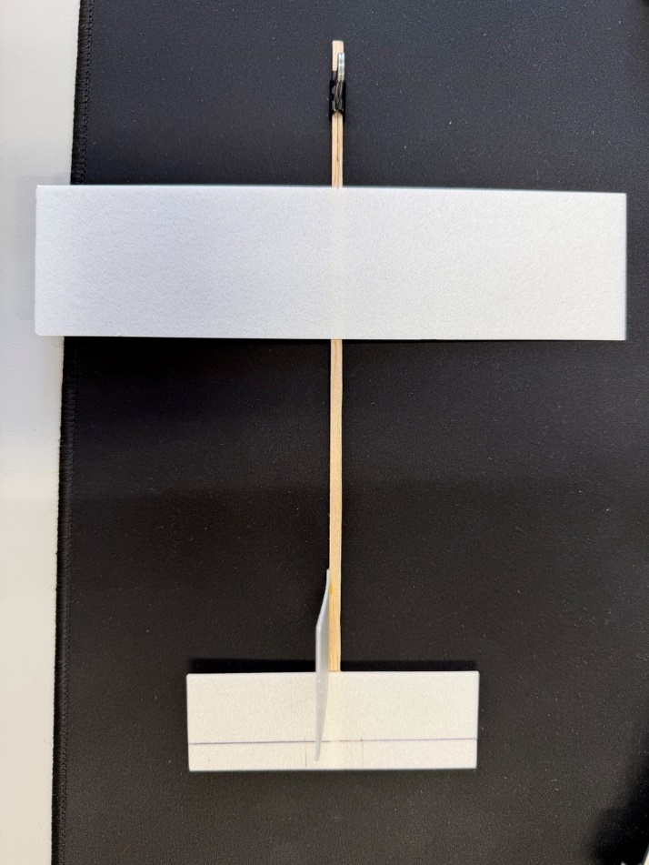
Fig. The glider

(2) Measure the specifications of the constructed aircraft

The measurement has been made on the constructed aircraft (glider). The dimensions, weights and positions of the aircraft’s components are measured.

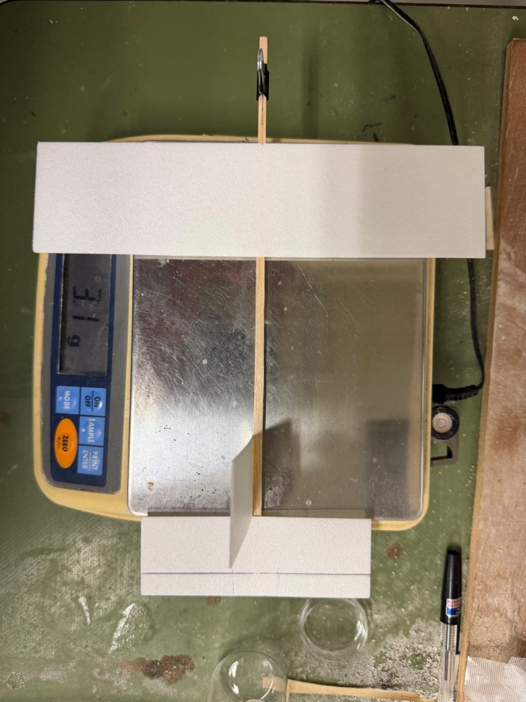
Fig. Glider (constructed aircraft) Weight measurement
The Total mass of the aircraft is 3.1 g. The main wingspan of the aircraft is 200 mm and has a chord length of 50 mm. It has a mass of 0.980 g. Its leading edge is positioned 50 mm from the nose along the fuselage. The horizontal stabilizer has a span of 100 mm and has a chord length of 35 mm, with a mass of 0.343 g. Its leading edge is positioned 215 mm from the nose of the body-axis. The vertical stabilizer has a width of 35 mm and height of 60 mm, and it has as mass of 0.206 g. and it is positioned before the horizontal stabilizer. The fuselage has a cross section of 3x3 mm, and length of 250 mm. It has a mass of 0.055 g. The aircraft has an added weight with a mass of 1.516 g position 15 mm from the nose of the fuselage.

(3) Determine the center of gravity position and moment of inertia
The Calculation of center of gravity position and moment of inertia is necessary because it can determine whether the aircraft is stable, how it will rotate, and how fast it responds to the external forces.
Center of gravity position can be calculated as:
$$\begin{aligned}\sum_{i}{\left(x_{i}-x_{cg}\right)m_{i}}=0\#\left(B6-1\right)\end{aligned}$$

Moment of inertia can be calculated as:
$$\begin{aligned}I_{yy}=\sum_{i}{{\left(x_{i}-x_{cg}\right)}^{2}m_{i}}\#\left(B6-2\right)\end{aligned}$$

From the calculation, the center of gravity position on the glider, $x_{cg}$, is 74.56 mm from the nose of the fuselage and the moment of inertia, $I_{yy}$, is $1.63 ×{10}^{-5}kgm^{2}$.
The aero dynamics center of main wing is located at 62.5 mm and the main wing’s lever arm from the CG,$l_{w}$, is - 0.01206 m. The horizontal stabilizer’s lever arm from the CG, $l_{t}$, is 0.14919 m. and its aerodynamic center is 223.75 mm from nose of the fuselage.

(4) Express the aerodynamic forces Xa and Za acting on the aircraft in terms of the aircraft state variables

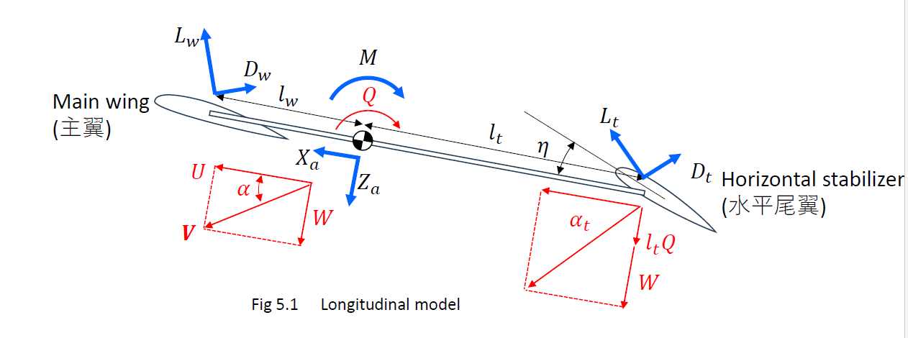
Fig. Longitudinal model
The aerodynamic forces along the aircraft x-axis ($X_{a}$) can be defined as:
$$\begin{aligned}X_{a}=L_{w}sinα+L_{t}sinα_{t}-D_{w}cosα-D_{t}cosα_{t}\#\left(B5-3\right)\end{aligned}$$

The aerodynamic forces along the aircraft z-axis ($Z_{a}$) can be defined as:
$$\begin{aligned}Z_{a}={-L}_{w}cosα-L_{t}cosα_{t}-D_{w}sinα-D_{t}sinα_{t}\#\left(B5-4\right)\end{aligned}$$
$$\begin{aligned}M=l_{w}L_{w}-l_{t}L_{t}\#\left(B5-5\right)\end{aligned}$$

Angle of attack of main wing can be defined as:
$$\begin{aligned}α_{w}≅α=\tan^{-1}\frac{W}{U}\#\left(B5-6a\right)\end{aligned}$$

Angle of attack of horizontal stabilizer can be defined as:
$$\begin{aligned}{ α}_{t}=\tan^{-1}\frac{W+l_{t}Q}{U}\#\left(B5-6b\right)\end{aligned}$$

Lift/Drag of main wing can be calculated as:
$$\begin{aligned}L_{w}=\frac{1}{2}ρV^{2}S_{w}C_{L_{w}}\#\left(B5-7a\right)\end{aligned}$$
$$\begin{aligned}D_{w}=\frac{1}{2}ρV^{2}S_{w}C_{D_{w}}\#\left(B5-7b\right)\end{aligned}$$

Lift/Drag of horizontal stabilizer can be calculated using:
$$\begin{aligned}L_{t}=\frac{1}{2}ρV^{2}S_{t}C_{L_{t}}\#\left(B5-7c\right)\end{aligned}$$
$$\begin{aligned}D_{t}=\frac{1}{2}ρV^{2}S_{t}C_{D_{t}}\#\left(B5-7d\right)\end{aligned}$$

Lift/Drag coefficient of main wing can be calculated using:
$$\begin{aligned}C_{L_{w}}=C_{L_{w0}}+α_{w}α_{w}\#\left(B5-8a\right)\end{aligned}$$
$$\begin{aligned}C_{D_{w}}=C_{D_{w0}}+\frac{{C_{L_{w}}}^{2}}{πe_{w}A_{w}}\#\left(B5-8b\right)\end{aligned}$$

Lift/Drag coefficient of horizontal stabilizer can be calculated using:
$$\begin{aligned}C_{L_{t}}=C_{L_{t0}}+α_{t}(α_{t}+η)\#\left(B5-8c\right)\end{aligned}$$
$$\begin{aligned}C_{D_{t}}=C_{D_{t0}}+\frac{{C_{L_{t}}}^{2}}{πe_{t}A_{t}}\#\left(B5-8d\right)\end{aligned}$$

Aspect ration of main wing and horizontal stabilizer can be calculated as:
$$\begin{aligned}S_{w}=b_{w}c_{w}\#\left(B5-9a\right)\end{aligned}$$
$$\begin{aligned}S_{t}=b_{t}c_{t}\#\left(B5-9b\right)\end{aligned}$$
$$\begin{aligned}A_{w}=\frac{{b_{w}}^{2}}{S_{w}}\#\left(B5-10a\right)\end{aligned}$$
$$\begin{aligned}A_{t}=\frac{{b_{t}}^{2}}{S_{t}}\#\left(B5-10b\right)\end{aligned}$$
Lift curve slope can be calculated as:
$$\begin{aligned}C_{l_{α}}=2π\#\left(B5-11\right)\end{aligned}$$
$$\begin{aligned}α_{w}=C_{l_{α}}\frac{A_{w}}{2+\sqrt{4+{A_{w}}^{2}}}\#\left(B5-12a\right)\end{aligned}$$
$$\begin{aligned}α_{t}=C_{l_{α}}\frac{A_{t}}{2+\sqrt{4+{A_{t}}^{2}}}\#\left(B5-12b\right)\end{aligned}$$

Since it is rectangular flat plate wing:
$$\begin{aligned}C_{L_{w0}}=C_{L_{t0}}=0\#\left(B5-13\right)\end{aligned}$$

Drag (bold approximation) for rectangular flat plate wing is:
$$\begin{aligned}e_{w}=e_{t}=1\#\left(B5-14\right)\end{aligned}$$
$$\begin{aligned}C_{D_{w0}}=C_{D_{t0}}=0.002\#\left(B5-15\right)\end{aligned}$$

Lift/Drag coefficient of horizontal stabilizer can also be defined as:
$$\begin{aligned}C_{L_{t}}=C_{L_{t0}}+a_{t}\left(α_{t}+τδ_{e}\right)\#\left(B6-3\right)\end{aligned}$$

The total aerodynamic forces are obtained by summing the lift and drag forces generated by the main wing and the horizontal stabilizer and resolving them into body-axis components. Therefore, the aerodynamic forces are nonlinear functions of the state variables.

(5) Implement the aerodynamic force model in the MATLAB program

The simulation is done in MATLAB by implementing the aerodynamic force model of the glider. The implemented code is expressed below.

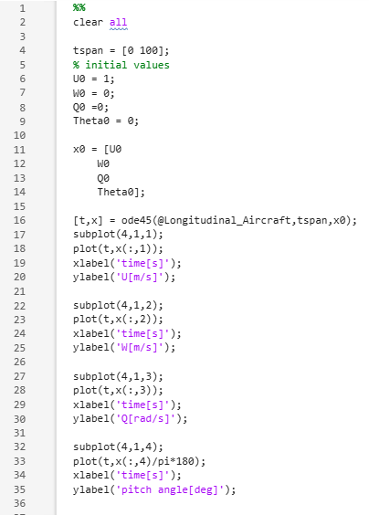
Fig. MATLAB code (“Dynamic_simulation.m”)

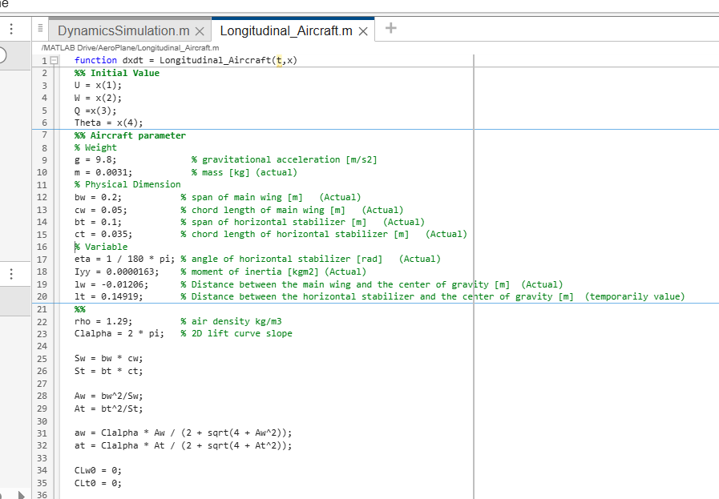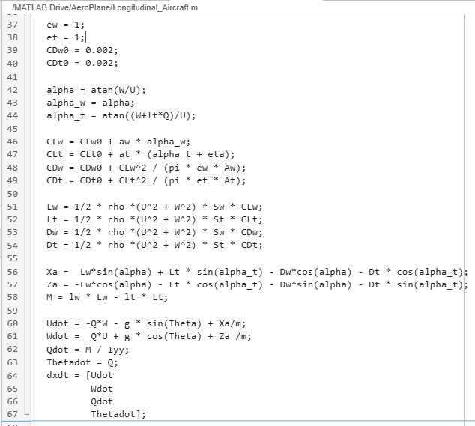
Fig. MATLAB code (“Longitudinal_Aircraft.m”)

The flowing are the results obtained from the MATLAB simulation. The graphs show the response of Forward Velocity (U), Vertical Velocity (W), Pitch Rate (Q) and Pitch angle (Θ) over time.

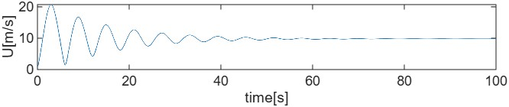
Fig. Forward Velocity (U) vs time (t)
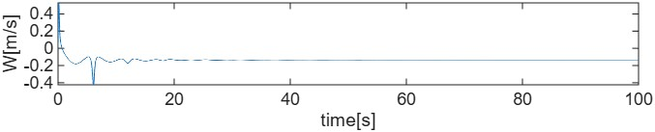
Fig. Vertical Velocity (W) vs time (t)
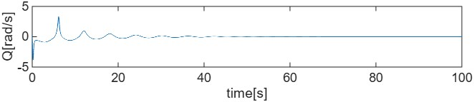
Fig. Pitch Rate (Q) vs time (t)
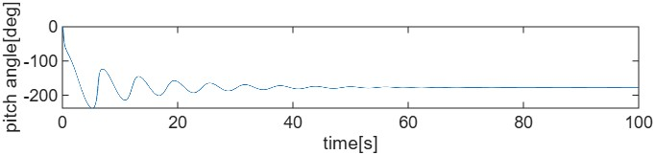
Fig. Pitch Angle (Θ) vs time (t)

The longitudinal simulation results show damped oscillatory behavior in forward velocity, pitch rate, and vertical velocity. The decay of oscillations confirms that the aircraft is dynamically stable. The aircraft shows two types of motion: slow oscillation (phugoid) and fast oscillation (short period). Both motions gradually decrease with time, which means they are damped and the aircraft are stable. Therefore, the glider exhibits stable longitudinal motion under the given mass distribution and aerodynamic configuration.

(6) Conduct simulations for various initial values

When I placed the extra weight at 105 mm from the nose of the fuselage, the center of gravity position, $x_{cg}$,is 116.13 mm, lever arm for main wing, $l_{w}$,is -0.05363 m and the lever arm for horizontal stabilizer, $l_{t}$, is 0.10763 m, and the moment of inertia, $I_{yy}$, is $7.86 ×{10}^{-6}kgm^{2}$. The output response of the simulation by placing the extra weight right behind the main wing is shown below.

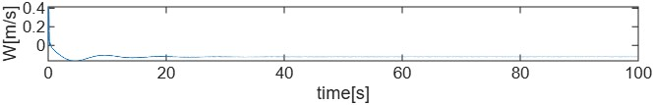
Fig. Forward Velocity (U) vs time (t)
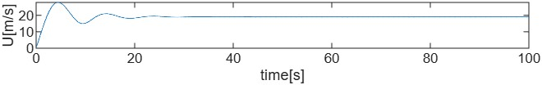
Fig. Vertical Velocity (W) vs time (t)
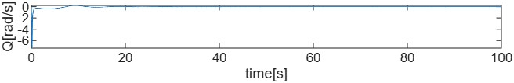
Fig. Pitch Rate (Q) vs time (t)
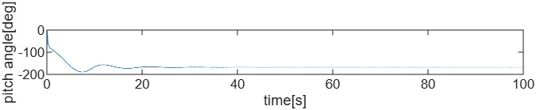
Fig. Pitch Angle (Θ) vs time (t)

When the extra mass is moved aft to 105 mm, the center of gravity shifts and the moment of inertia decreases significantly. As a result, the aircraft responds faster and the oscillations in forward velocity, pitch rate, and vertical velocity decay more quickly compared to the previous configuration. Both configurations remain dynamically stable; however, the second configuration shows reduced oscillation amplitude and faster damping due to the smaller moment of inertia and altered moment arms.
The output responses of the aerodynamic model simulations when the eta value is set to 0 are shown below.
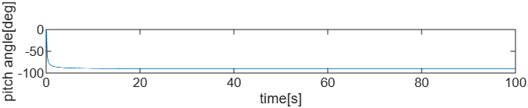
Fig. Forward Velocity (U) vs time (t)
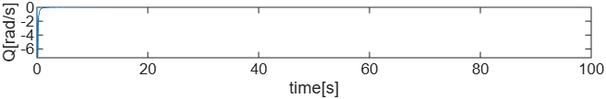
Fig. Vertical Velocity (W) vs time (t)
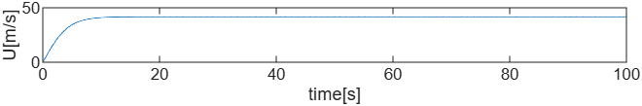
Fig. Pitch Rate (Q) vs time (t)
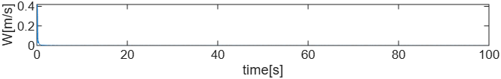
Fig. Pitch Angle (Θ) vs time (t)

When the tail incidence angle is set to η = 0, the oscillations in forward speed, vertical speed, and pitch rate almost disappear. The variables $U$, $W$, and $Q$quickly converge to steady values, which shows very strong damping. Compared with the η = 1° case, both the phugoid and short-period oscillations are much smaller and settle faster. However, the steady pitch angle becomes a large negative value, and the steady speed becomes much higher, meaning the trim equilibrium changes significantly when η is set to zero.

THU TA ZAW
2415121095

